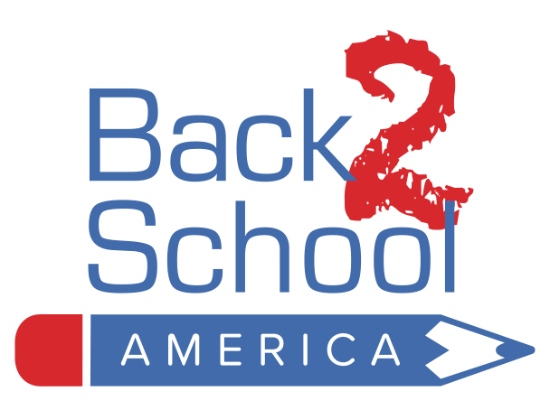

Back 2 School Program – 2023 Kit Contents

Pre-Kindergarten -1st Grade Kit

1 Construction Paper Pad - 9" x 12", 50 Sheets, Assorted Colors
2 Folder - 2 Pocket, Assorted Colors
1 Notebook - Spiral, 1 subject, Perforated, 70 pages, Wide Rule
1 Composition Notebook
1 Box Facial Tissue - 2-ply, 100 Count
1 Pencil Case - Fabric, 3-Hole w/Grommets
1 Box (8 count) Markers - Washable, Assorted Colors, Fine Tip
1 Box Crayons - 24 Count, Assorted Colors
1 Box (Dozen) Pencils - #2, Sharpened, All Wood
1 Glue Bottle - Washable, 4oz., White
3 Glue Sticks - Washable, White, .26 Ounce Each
3 Eraser - Pink, Large, Latex-Free
1 Scissors - 5", Blunt Tip
1 Ruler -12", Plastic, Inch & Centimeters, Center Holes
1 Sharpener - For Pencil & Crayon, Double Barrel, Canister
1 Package (12 count) Erasers - Pencil Cap
2 Pens - Stick, medium point, BLUE ink
1 Back 2 School America Flier (6” x 8”)
1 Internet Essentials Low-Cost Internet Brochure (select cities)
1 Note of Inspiration (subject to availability)

5/26/22

