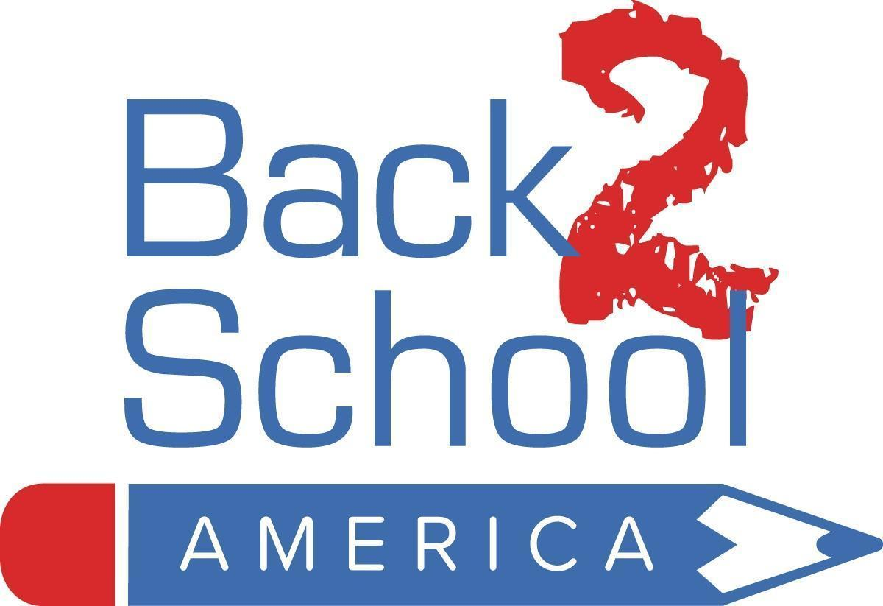

2024 Teacher Classroom Kit Contents

6th - 12th Grade Kit

25 Pocket Folders
5 Tissue Boxes
10 Pencil Sharpeners
10 Rulers
10 Glue bottles
10 Colored pencils (10)
10 #2 Pencils (12)
200 Blue Pens
100 Red Pens
5 Spiral Notebook - Wide Ruled
5 Spiral Notebook - College Ruled
5 Filler Paper - College Ruled
5 Filler Paper - Quad Ruled (Graph)
5 Filler Paper - Wide Ruled
5 Composition Notebooks
24 Highlighters
10 Scissors (Pointed)
10 Erasers
10 Sticky Notes
5 Index Cards
10 Protractors
5 Fabric Pencil Bag
20 Glue Sticks
504 Total Number of Supplies

4/14/24

